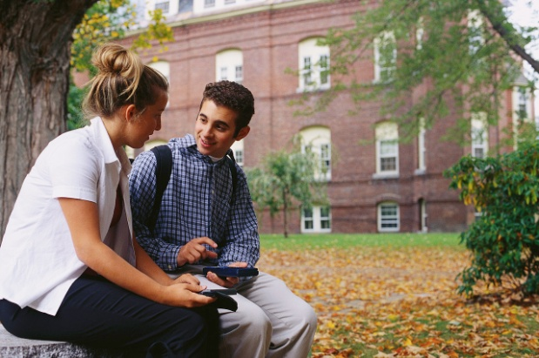
STATE UNIVERSITY
2011 Bulletin for Students and Parents
Personal Safety on Campus
July 14, 2011

Overview
State University prides itself as having one of the safest campuses in the entire northeast. Still, it cannot be stressed enough that personal safety, either on campus or off, is a shared responsibility. Students must understand that our campus security measures are only as effective as the precautions students take to ensure their own safety. In response to concerns over a 2010 incident in which a male student was accosted and robbed by a local resident, State University has prepared this bulletin as a primer on personal safety. Please talk with your student before the 2011-2012 school year begins about this increasingly important issue. If you have questions or specific concerns, please feel free to call our Campus Security Department at (555) 555.1212.

A Message from the President:
At State University, we consider the safety of our students and faculty of utmost importance. During the first week of classes, we will be offering daily seminars on campus safety. Students are strongly encouraged to attend one of these sessions.

Personal Safety

Know Your Surroundings
If you detect suspicious activity, act immediately to remove yourself from danger. If you find yourself in a dangerous situation, follow these steps:
- Trust your instincts and don’t take unnecessary risks.
- Call for attention while moving to a lighted or populated area.
- Call campus police (x1099) or 911.
- If there is a fire alarm nearby, activate it.
- If necessary, defend yourself with your keys or a pen.
- Get yourself out of the situation as quickly as possible.

At Home
Discuss safety issues with your roommates and make sure you all have an understanding when it comes to safety. Agree to keep doors and windows locked, especially at night. Keep important safety numbers near your phone (see the end of this bulletin). Never open the door for strangers or let strangers into the building, even if they claim to be friends with a resident. Take the following individual precautions:
- Never leave messages on your door announcing your whereabouts.
- Always have your keys ready before reaching the door.
- Never loan your keys to anyone.
- Never prop open an entry door.
- Do not write your name or address on your keys.
- Report any defective locks immediately.

Property Safety
Perhaps the most common yet preventable crime on college campuses is property theft. Following is a list of the most commonly stolen items:

- MP3 players
- Cash
- Jewelry
- Bicycles
- Skateboards
- Laptops
- Wallets/Purses
- Backpacks
- CDs/DVDs
- Books
- Cell phones
- Creditcards

Take the same precautions you would use to protect yourself. There is no need for flashy or expensive jewelry on campus; leave especially valuable jewelry in the safety of your home. Remember that you have to rely not only on yourself taking precautions, but also your roommates being responsible for your belongings, so discuss this with them. Never carry large amounts of cash and never leave your belongings unattended in the library or other common areas. Keep a list of serial numbers in case stolen property is recovered. Consider registering your bicycle with the SUCSS–sponsored retrieval program.

Common Safety Tips
- Always carry your cell phone. Important numbers are given at the end of this bulletin.
- Carry a safety whistle, available free of charge at the Student Center.
- Learn to defend yourself with unconventional weapons, such as your keys or a pen.
- Avoid walking alone or in poorly lit areas at night. Use the “Buddy System.”
- If you must walk at night, get a portable flashlight.
- Be prepared. Know how you will respond beforehand.
- Consider taking a self-defense course.
- Keep your purse or handbag draped over your shoulder.
- Never hitch a ride with someone you do not know.
- If walking or jogging near the road, always face oncoming traffic.

Important Numbers
Campus PD x1099 Strickland Hall, 211
City Police 911 34 Post Road
Fire Dept 555.3123 7 Post Road
Hospital 555.1234 19 Liberty Street
Campus MD x1010 Strickland Hall, 110

